OFFLINE ACTIVITY · YEAR 4 SCIENCE · AC9S4U02

Puddle watch and bag watch.
Part A: one day after rain · Part B: three days · Chalk, a ruler, a zip-lock bag
Name: ______________________________ Class: ______________
Water is always on the move, but it moves without being seen. In these two activities you will watch it go, and watch it come back.

Part A · Puddle watch
- After rain, find a puddle on a path or playground (not a car park). Draw around its edge with chalk. Write the time next to the line.
- Measure across the widest part with a ruler or tape. Write it in the table, with the weather.
- Come back about two hours later. Chalk around the edge again, measure again, and write it down.
- Do it a third time. If the puddle has gone, write 0 and describe what is left.
Time | Weather (sunny, cloudy, windy) | Widest part (cm) | What the puddle looks like

Draw the three chalk lines, one inside the other, and write the time on each
- Where do you think the puddle water went?

- What would make a puddle disappear faster? What would make it slower?

Part B · A water cycle in a bag
You need: a zip-lock sandwich bag, water, one drop of blue food colouring, sticky tape, a marker, and a window that gets sun.
- Draw a sun, a cloud and some waves on the bag with the marker.
- Pour in water to about a finger deep. Add one drop of food colouring. Seal the bag well.
- Tape it to the window in the sun. If you can, tape a second bag to a shady window.
- Look at the bag in the morning and the afternoon for three days. Draw what you see each day.
Day 1 · time: | Day 2 · time: | Day 3 · time:
- The bag was sealed. Where did the drops on the inside of the bag come from?

- What did the sun do to the water? How do you know?

- If you had a shady bag too: how was it different? Why?

Part C · Name the cycle
Write the right word next to each number. Words: evaporation, condensation, precipitation, run-off, soaking in, flowing to the sea.
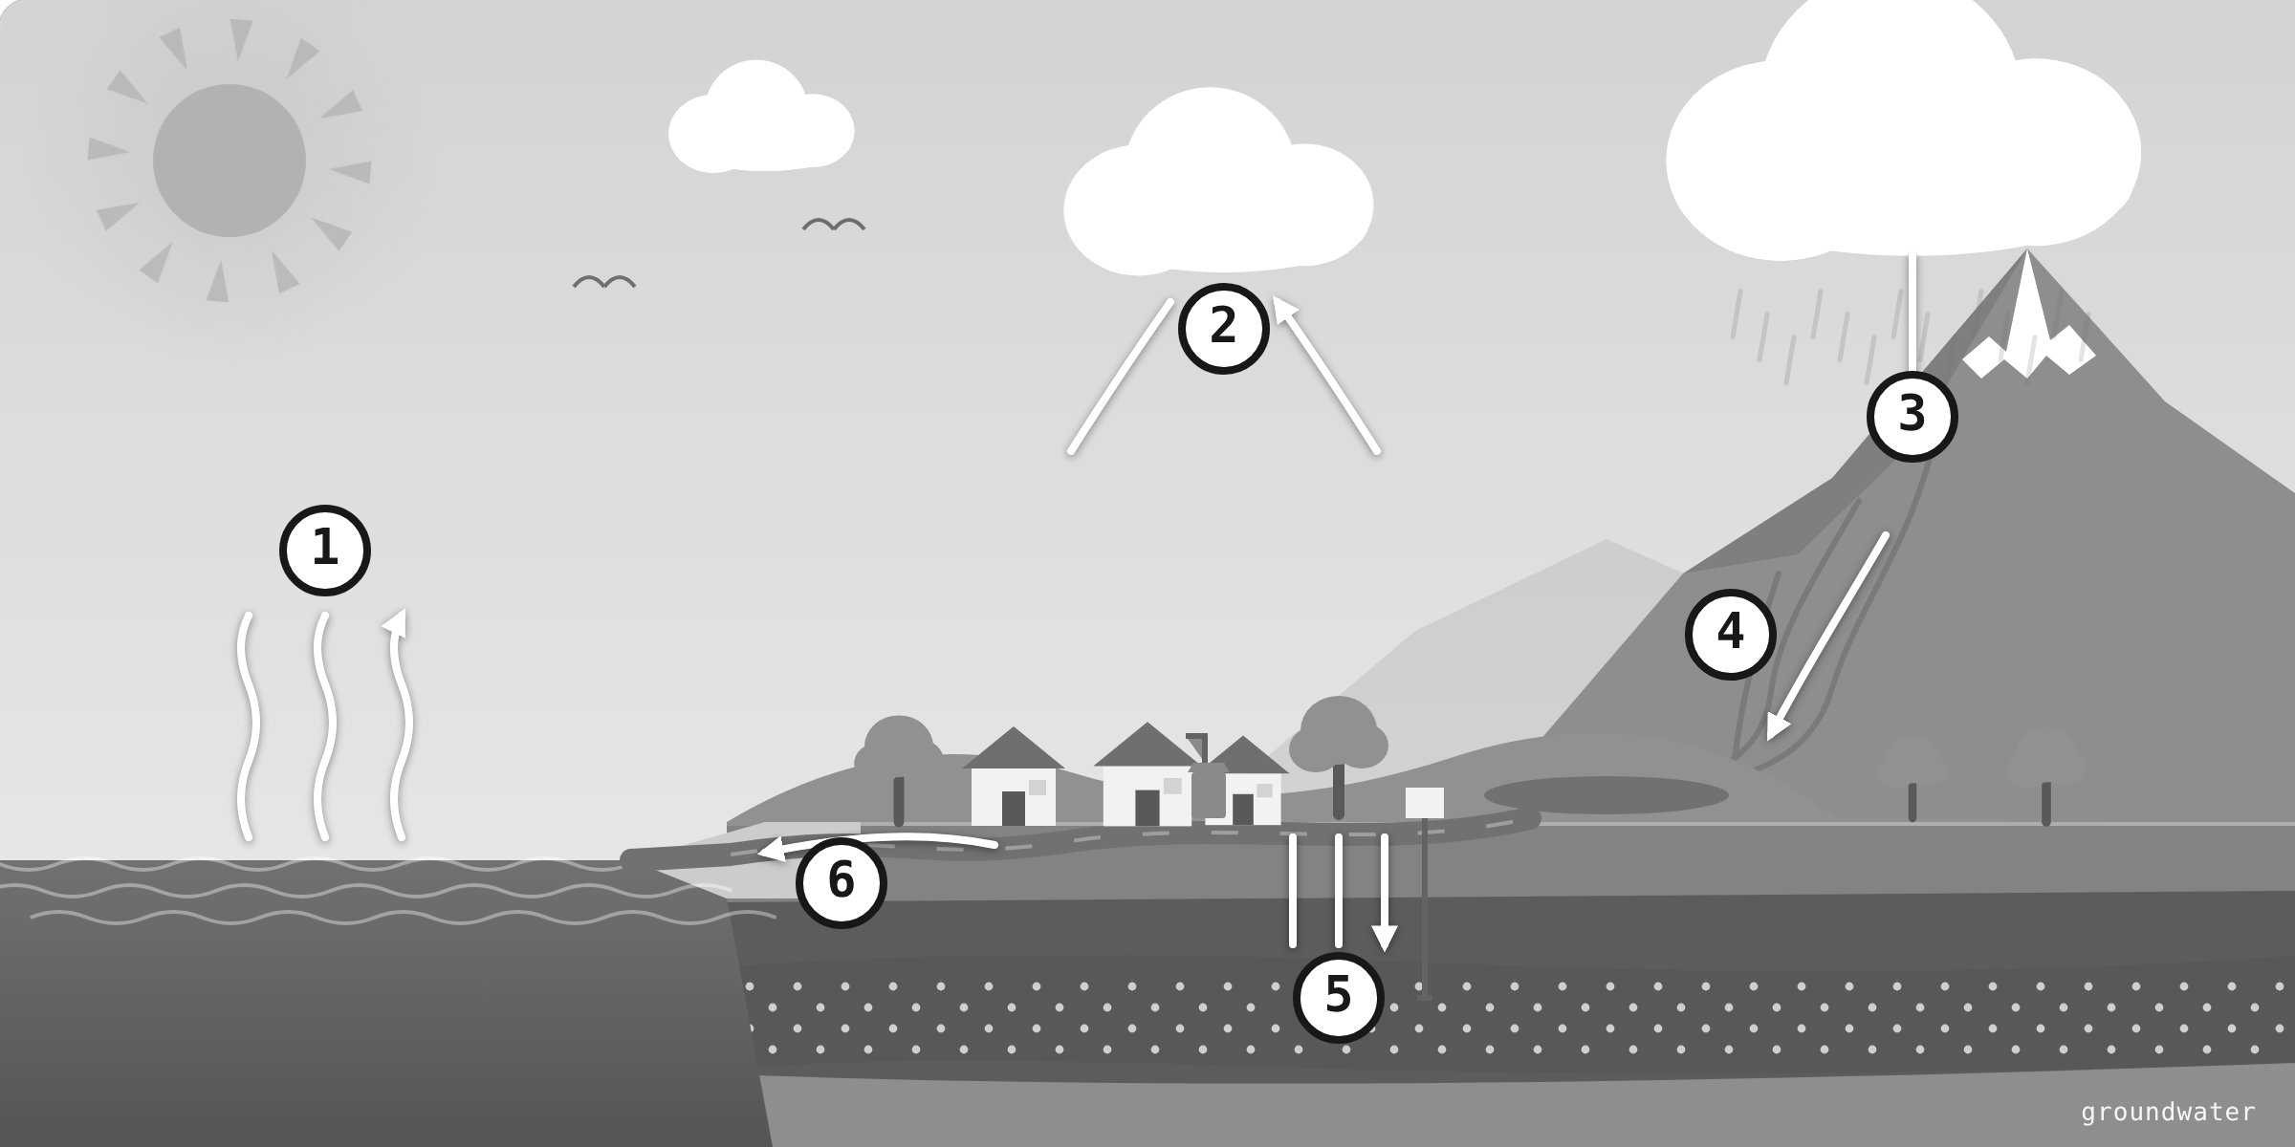
1 __________________________________ | 2 __________________________________
3 __________________________________ | 4 __________________________________
5 __________________________________ | 6 __________________________________
- Draw your own water cycle for the place where you live. Put in the sun, a cloud, rain, the land, and where the water goes. Label it with the words you know.

FOR THE TEACHER · NOT FOR STUDENTS

Notes and answers
Purpose
Two observations over time, then the words. Part A gives students evaporation they can measure; Part B gives them the whole cycle in a sealed system, where the water cannot have gone anywhere else. Part C checks the six words from screen 5 of the online lesson. The sheet stands on its own if the lesson is not used (AC9S4U02; Science Inquiry: observing and recording over time, fair testing).
Running it
- Part A needs a puddle, so keep the sheet ready for the day after rain. Three measurements two hours apart fit a school day. A car park is off limits.
- Part B is best started on the day of the first lesson so the three days are done by the Explain session. A finger-depth of water is plenty; too much slows everything down. A second bag in the shade turns it into a fair test.
- Food colouring stains clothes. Tape on glass only.
What to expect, and answers
- (1) On a sunny day a small puddle on asphalt usually goes in two to four hours. Most of the water evaporates; a little soaks through cracks. Accept either, and push for both. “It dried up” only restates the question; ask where it went.
- (2) Faster: sun, warmth, wind, a shallow wide puddle. Slower: shade, cloud, cold, still air, a deep puddle.
- Part B: mist on the inside by the first sunny afternoon, drops by day two, drops running down into the water by day two or three. The shady bag does far less.
- (3) From the water in the bag. It evaporated, rose as water vapour, condensed on the cooler plastic and ran back down. Nothing got in or out.
- (4) The sun warmed the water, which made it evaporate faster. The shady bag, with less sun, shows this.
- (5) The shady bag stays almost clear for longer and makes fewer drops. Less warmth, less evaporation.
- Part C: 1 evaporation, 2 condensation, 3 precipitation, 4 run-off, 5 soaking in, 6 flowing to the sea.
- (6) Look for the sun, a cloud, rain, the land and at least one place the water goes (a river, the sea, the ground, a tank), with at least the three big words used correctly.
Extension
- Two identical dishes of water, one in sun and one in shade, with the level marked each day for a week: evaporation you can measure in millimetres, like the weather stations do.
- Breathe on a cold window or mirror and watch the mist come and go. Where did it come from, and where did it go?

