QCE EARTH & ENVIRONMENTAL SCIENCE · UNIT 3 TOPIC 1: USE OF NON-RENEWABLE EARTH RESOURCES

Coal seam gas: practice data test.
Name: ______________________________ Class: ____________ Date: ____________
Perusal: 2 minutes. Working time: 25 minutes. You may use a calculator. Datasets A and C are model data; dataset B is real. Answer in the spaces on pages 3 and 4, and show your working for calculations.
DATASET A Well 4 and Block D Model data
Well 4: density log  Depth below the surface (m) down the side; density (g/cm³) across. Each reading covers 0.5 m.  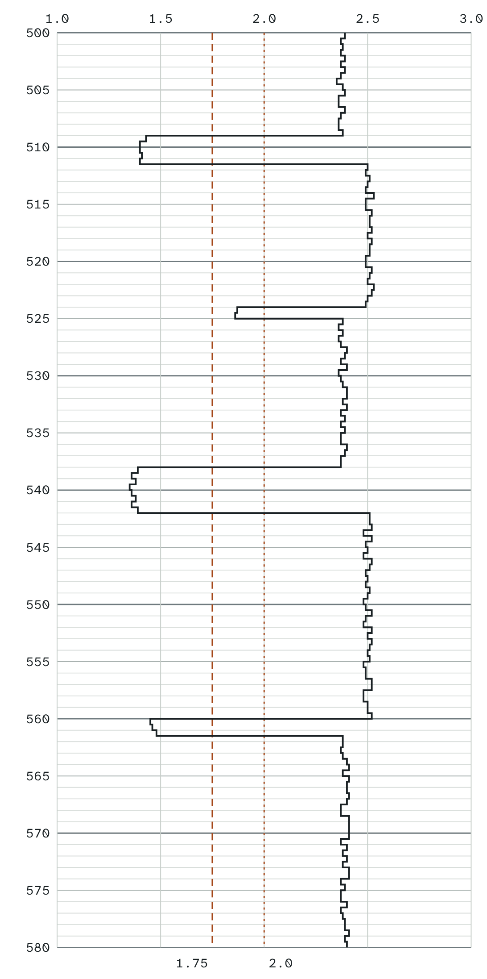 | Well 4 is in Block D, which covers 1.5 km². The coal in Block D has a density of 1.45 g/cm³. Three samples of the coal from Well 4 were tested for their gas content.  Gas content of the coal samples  Coal with little ash is below 1.75 g/cm³, and coal with a lot of ash below 2.0 g/cm³ (Lange, 2003). The dashed lines on the log mark 1.75 and 2.0.
  Sample | Gas content (m³/t)
  1 | 3.8
  2 | 4.6
  3 | 5.4

DATASET B Water bores predicted to be affected Real data
Long-term affected area: bores predicted to pass the trigger threshold at any time
Formation, in the order OGIA lists them | Bores
Alluvium (Main Range Volcanics) | 1
Westbourne Formation | 9
Gubberamunda Sandstone | 2
Springbok Sandstone | 103
Walloon Coal Measures | 321
Hutton Sandstone | 8
Bandanna Formation | 1
Existing bores | 445
Bores with make good agreements, decommissioned, or of uncertain status | 302
All long-term affected bores | 747

Immediately affected area: bores predicted to pass the trigger threshold in 2026 to 2028
Formation | Bores
Springbok Sandstone | 20
Walloon Coal Measures | 56
All immediately affected bores | 76

Most of the gas comes from the Walloon Coal Measures. The Springbok Sandstone lies above them, and the Hutton Sandstone below. A bore’s trigger threshold is a fall in water level of 5 m in a consolidated aquifer, or 2 m in an unconsolidated aquifer.
Source: OGIA, Underground water impact report 2025 for the Surat Cumulative Management Area, consultation draft, Tables 11-1 and 11-4. The parts of the Springbok Sandstone and the Walloon Coal Measures are added together.
DATASET C Two monitoring bores Model data
Bore X, sandstone  Drawdown since 2019 (m), with the trigger threshold of 5 m (dashed).  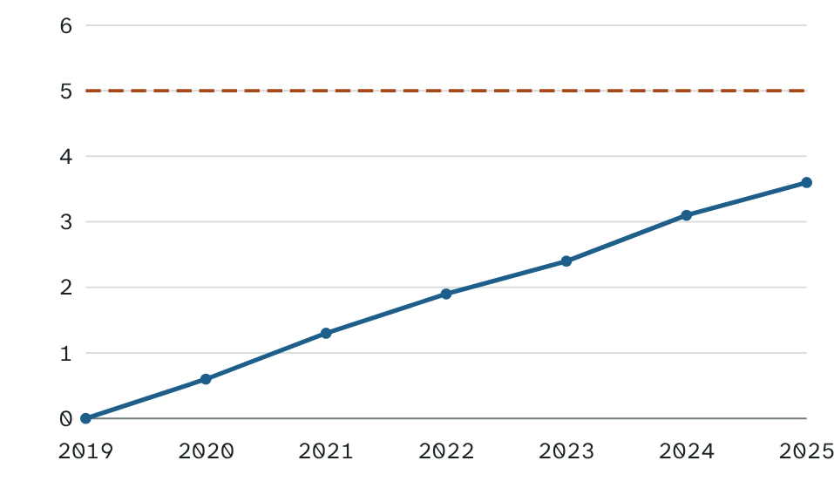 | Bore Y, river alluvium  Drawdown since 2019 (m), with the trigger threshold of 2 m (dashed).  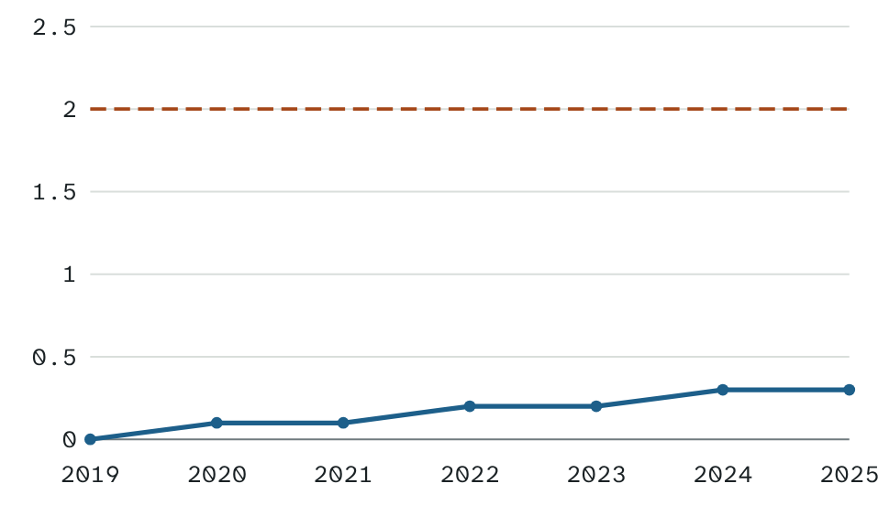

Drawdown (m) | 2019 | 2020 | 2021 | 2022 | 2023 | 2024 | 2025
Bore X | 0.0 | 0.6 | 1.3 | 1.9 | 2.4 | 3.1 | 3.6
Bore Y | 0.0 | 0.1 | 0.1 | 0.2 | 0.2 | 0.3 | 0.3

Bore X draws water from sandstone, a consolidated aquifer. Bore Y draws water from river alluvium, an unconsolidated aquifer.
Questions. The tag beside each question says what kind it is and which dataset it uses.
1 WORK OUT · DATASET A What is the net thickness of coal with little ash in Well 4?

2 WORK OUT · DATASET A Using the middle gas content, calculate the gas in place in Block D. Show your working.

3 WORK OUT · DATASET C Calculate the average rate of drawdown in Bore X from 2019 to 2025.

4 TRENDS AND LIMITS · DATASET B Identify the pattern in which formations hold the existing long-term affected bores.

5 TRENDS AND LIMITS · DATASET C Compare the trends in Bores X and Y.

6 TRENDS AND LIMITS · DATASET A Identify two sources of uncertainty in your answer to question 2.

7 CONCLUDE · DATASET C Predict when Bore X will pass its trigger threshold, and state the assumption you made.

8 CONCLUDE · DATASET C In 2025, should Bore Y have a bore assessment? Justify your answer.

9 CONCLUDE · DATASET B Infer why most of the affected bores draw water from the Walloon Coal Measures.

10 CONCLUDE · DATASET A Block D will only make a profit if it holds at least 70 million m³ of gas. Using your answers to questions 2 and 6, justify whether the company should develop Block D now. Use up to 150 words.

