QCE EARTH & ENVIRONMENTAL SCIENCE · UNIT 3 TOPIC 1: USE OF NON-RENEWABLE EARTH RESOURCES

Draw the traps.
Name: ______________________________ Class: ____________ Date: ____________
Oil and gas form in a source rock, then rise through porous rock until something stops them. Where the rocks stop them, they collect in a trap. The layers of four common traps are drawn below and over the page. Finish each one so that it shows how the trap works.
EVERY TRAP NEEDS  - a reservoir rock with connected spaces, such as sandstone  - a seal that oil and gas cannot pass through, such as shale or salt  - a shape that closes off the top, so they collect at a high point |  | COLOUR KEY
   | Sandstone (dotted): yellow |  | Shale: grey
   | Source rock: black |  | Salt: pink
   | Gas: red |  | Oil: green
   | Water: blue |  | Other rock: leave white

Method
- Find the layers. The dotted layer is sandstone, the reservoir rock, with shale over it. The source rock is the layer just above the bottom one.
- Colour the sandstone, shale, source rock and salt, using the key.
- In the sandstone, show where the oil and gas collect: gas at the top, then oil, then water below.
- Draw arrows to show how the oil and gas moved out of the source rock and into the trap.
- Label the source rock, reservoir rock, seal, gas, oil and water. Then answer the question under each drawing.

1 Anticline trap  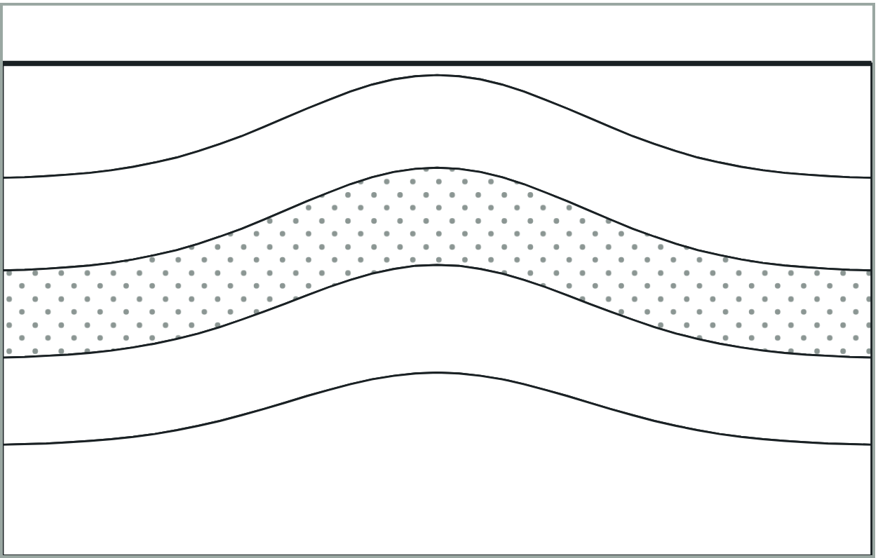  What stops the oil and gas here? |  | 2 Fault trap  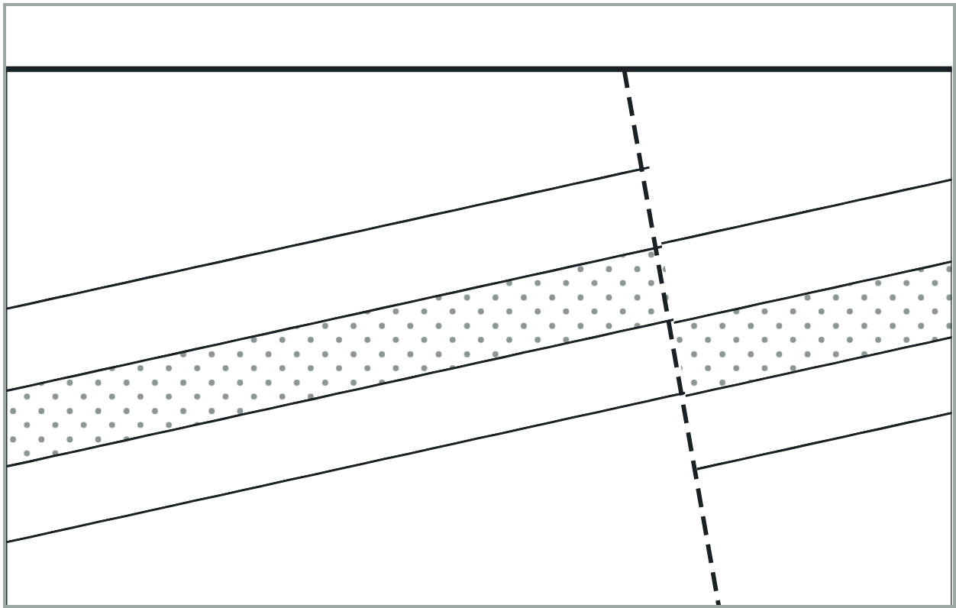  What stops the oil and gas here?

3 Salt dome trap  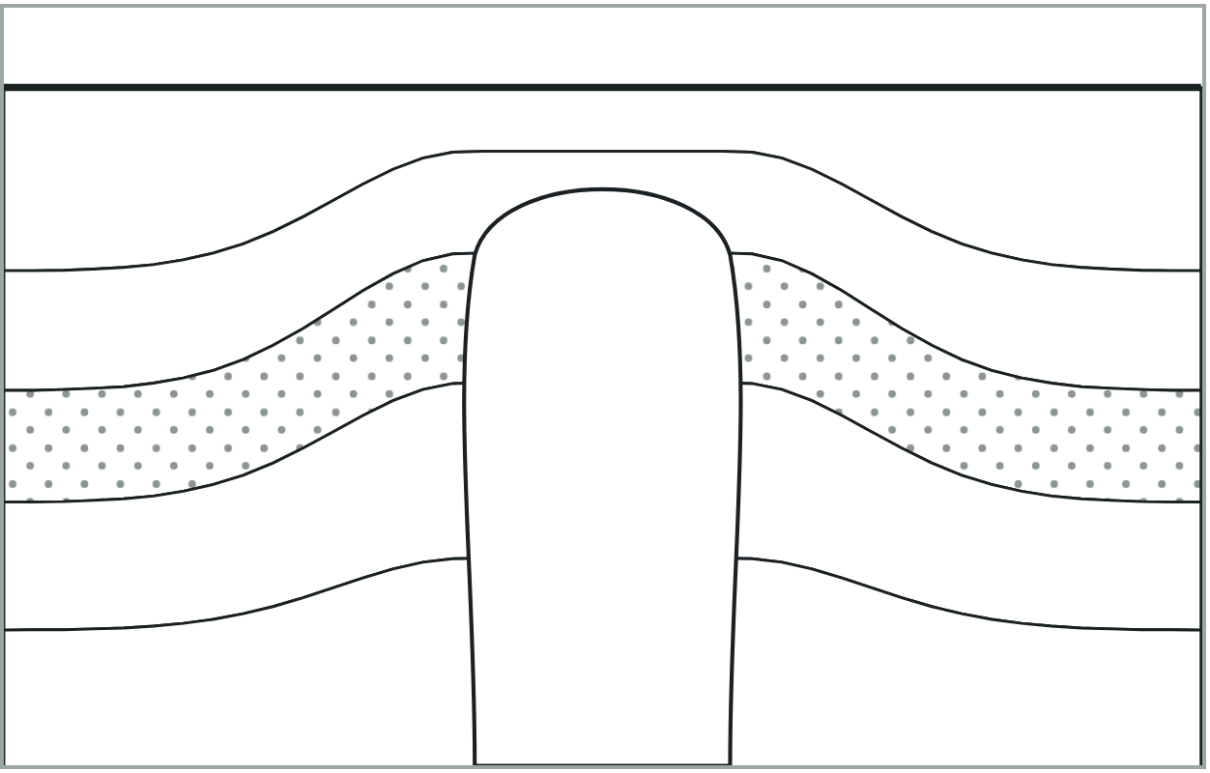  What stops the oil and gas here? |  | 4 Stratigraphic trap  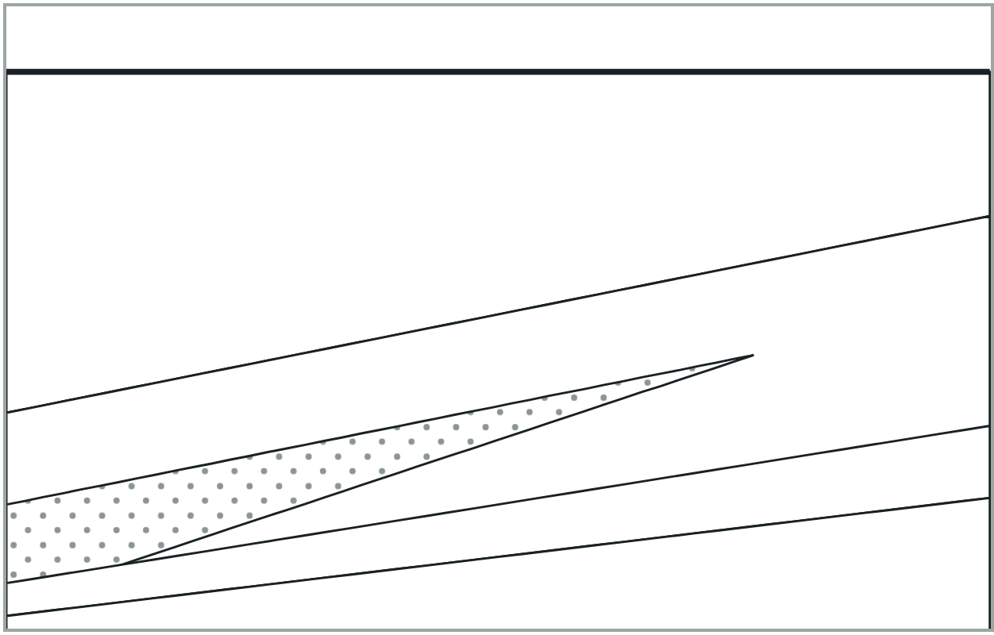  What stops the oil and gas here?

Questions
1 In every trap, gas collects above oil, and oil above water. Explain why.

2 Which of your traps are structural, and which is stratigraphic? Explain the difference between the two kinds.

3 Choose one of your traps. Describe one way it could fail and let the oil and gas escape to the surface.

4 An explorer drills into trap 1 but finds only water. Where might the well be, and why?

5 Coal seam gas is not held in a trap like these. How is it held instead, and what must be done to get it out?

