OFFLINE ACTIVITY · YEAR 8 GEOGRAPHY · AC9HG8S02

Field sketch.
About 40 minutes · On your own or in pairs · Pencil, eraser, two coloured pencils
A field sketch is a quick drawing of a landscape, with labels and notes that explain it. Geographers use field sketches to record what they see and to show how it formed. Clear lines and good notes matter much more than artistic skill.

Choose a landscape
OPTION A The lookout at Nitmiluk Gorge
Sketch from this illustration of the view from Site 1 in the lesson.
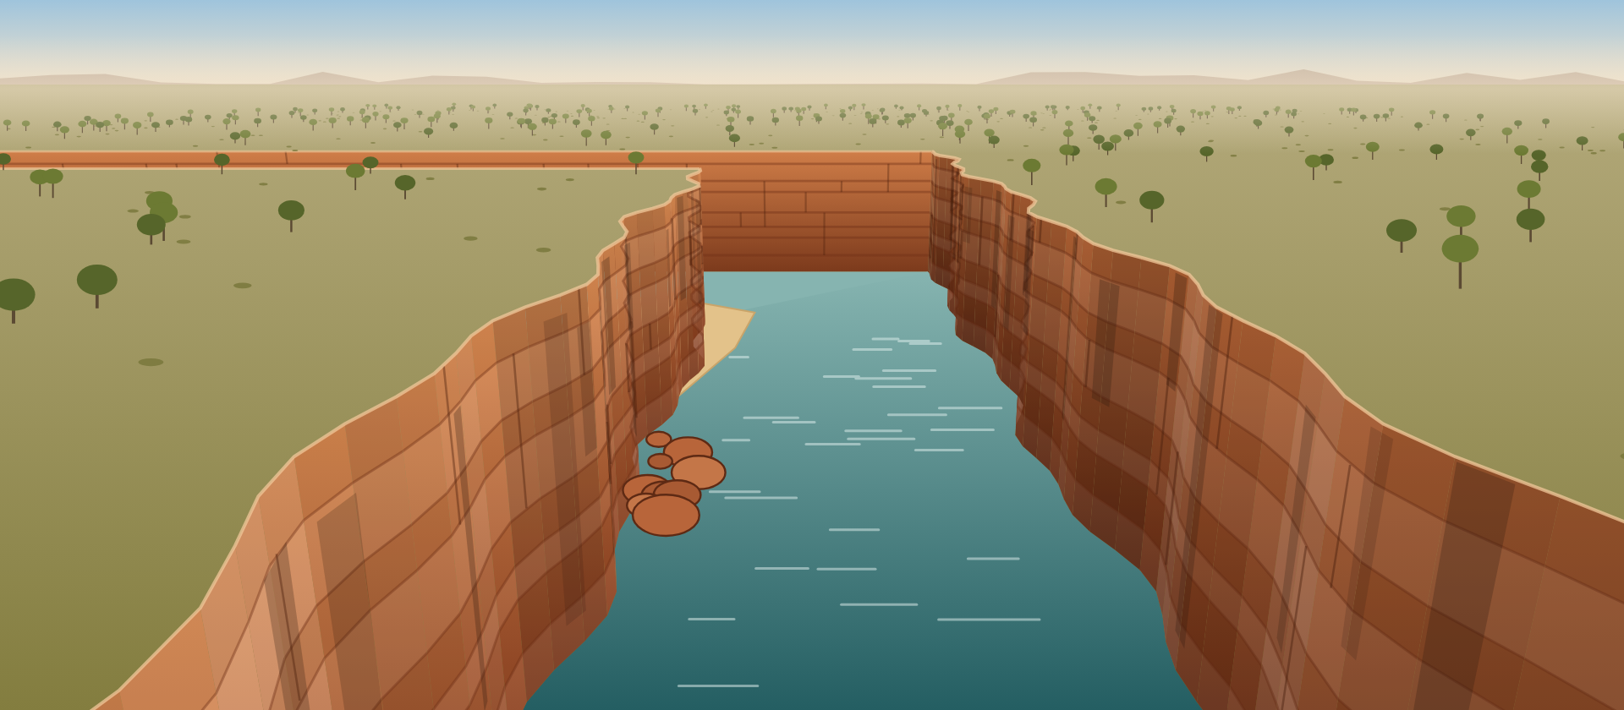

OPTION B A landscape near you
Find a view near your school or home: a creek, a hill, a road cutting, a beach or a park. Only work where your teacher or a parent says it is safe.

How to draw it
- Frame it. Use the frame on the next page. Lightly draw the horizon about a third of the way down.
- Split the view. The dashed lines divide the frame into background, middle ground and foreground. Sketch the biggest shapes first: the skyline, the slopes and any river or road.
- Add what matters. Add the landforms and a few details, such as layers in rock, boulders, trees or buildings. Leave out anything that does not help explain the landscape.
- Label. Label at least five features with arrows. Use one colour for natural features and another for human features.
- Annotate. Add at least three notes that explain how something formed or is changing. For example: “boulders: fell from the cliff (rockfall)”.
- Finish. Add a title, the place, the date, the direction you are facing and the words “not to scale”.
LANDFORMS plateau · cliff · gorge · valley · slope · river · sand bank · floodplain · boulders · rock layers · joint
PROCESSES weathering · erosion · rockfall · deposition

TITLE | PLACE | DATE | FACING

BACKGROUND
MIDDLE GROUND
FOREGROUND

My three annotations
How did each feature form, or how is it changing? Name the process.
1.

2.

3.

Check your sketch
☐ Title, place, date and direction | ☐ Horizon about a third of the way down
☐ Background, middle ground and foreground | ☐ At least five labels with arrows
☐ At least three annotations that name a process | ☐ “Not to scale”

FOR THE TEACHER · NOT FOR STUDENTS

Notes
Purpose
Students collect and represent information from fieldwork (AC9HG8S02) and explain landforms using geomorphological processes (AC9HG8K01). The activity goes with the online lesson, especially Site 1 and Site 4, but students can complete it without the lesson.
Running it
- Option A works anywhere, including at home. The illustration is the lookout view from the lesson.
- For Option B, look for a safe place with a clear view: a slope, a drain or creek, a road cutting or a sports field and its surroundings. Follow your school’s policy for supervision and sun safety.
- If students cannot go outside, project a photo of a local landscape and sketch from that.
- Allow about 10 minutes for the sketch itself, then time for labels and annotations.
What a strong sketch shows
- A frame, a horizon and the three zones, with big shapes rather than detail.
- At least five labelled features, with natural and human features in different colours.
- Annotations that name a process and say what it did, not just what a feature is.
- Title, place, date, direction faced and “not to scale”.
Sample annotations for Option A
- Plateau: flat, wooded land on top of the sandstone.
- Cliffs: steep walls with flat beds of sandstone and vertical joints. Weathering loosens the rock.
- The gorge turns sharply at the far end, because the river follows the joints.
- Boulders at the foot of the left cliff: blocks that broke away and fell (rockfall).
- Sand bank on the inside of the bend: slow water drops sand (deposition).
- River: erodes its bed most during wet season floods, when it can move boulders.
Extension
- Draw a cross-section across the gorge, from one rim to the other, and label the layers.
- Compare an Option B sketch with a satellite image of the same place. What does each show that the other does not?

