OFFLINE ACTIVITY · YEAR 10 SCIENCE · AC9S10U04

Argue from the data.
About 50 minutes, plus review · In pairs, then swap with another pair · Pencil, ruler
The guiding question: Australia has warmed by about 1.5 °C since 1910. What is driving it, and how do we know? Three records, averaged by decade: the temperature, the carbon dioxide in the air, and the activity of the Sun. Plot them, compare their shapes, then build and defend an argument.

The data
Decade | Temperature anomaly (°C) | CO2 (ppm) | Sunspot number
1910s | −0.45 | 301 | 65
1920s | −0.44 | 305 | 70
1930s | −0.35 | 308 | 85
1940s | −0.45 | 311 | 109
1950s | −0.31 | 314 | 130
1960s | −0.20 | 320 | 86
1970s | −0.13 | 329 | 87
1980s | +0.23 | 343 | 114
1990s | +0.40 | 358 | 94
2000s | +0.58 | 376 | 76
2010s | +0.86 | 397 | 54
Temperature: Bureau of Meteorology ACORN-SAT annual anomalies relative to 1961 to 1990, averaged by decade (the 2010s are 2010 to 2019). CO2: Law Dome ice core to 1975, then Cape Grim (CSIRO and the Bureau). Sunspots: SILSO yearly means, averaged by decade.

What to do
- Plot each decade’s value as a cross on the three grids on the next page. The grids share the same decades, so the shapes line up.
- Join the crosses on each grid with straight lines.
- Compare the shapes. Which of the two candidate causes rises and falls with the temperature? Which does not?
- Build the argument: claim, evidence with numbers, reasoning.
- Swap with another pair and review each other’s arguments with the peer review sheet. Revise yours.
Two fingerprints to use as well
Satellites have measured the stratosphere (12 to 50 km up) cooling since 1979 while the surface warmed. A brighter Sun would warm both; greenhouse gases warm the surface and cool the stratosphere. And the 1963, 1982 and 1991 eruptions each cooled the planet by about half a degree for one to two years, then the warming resumed.

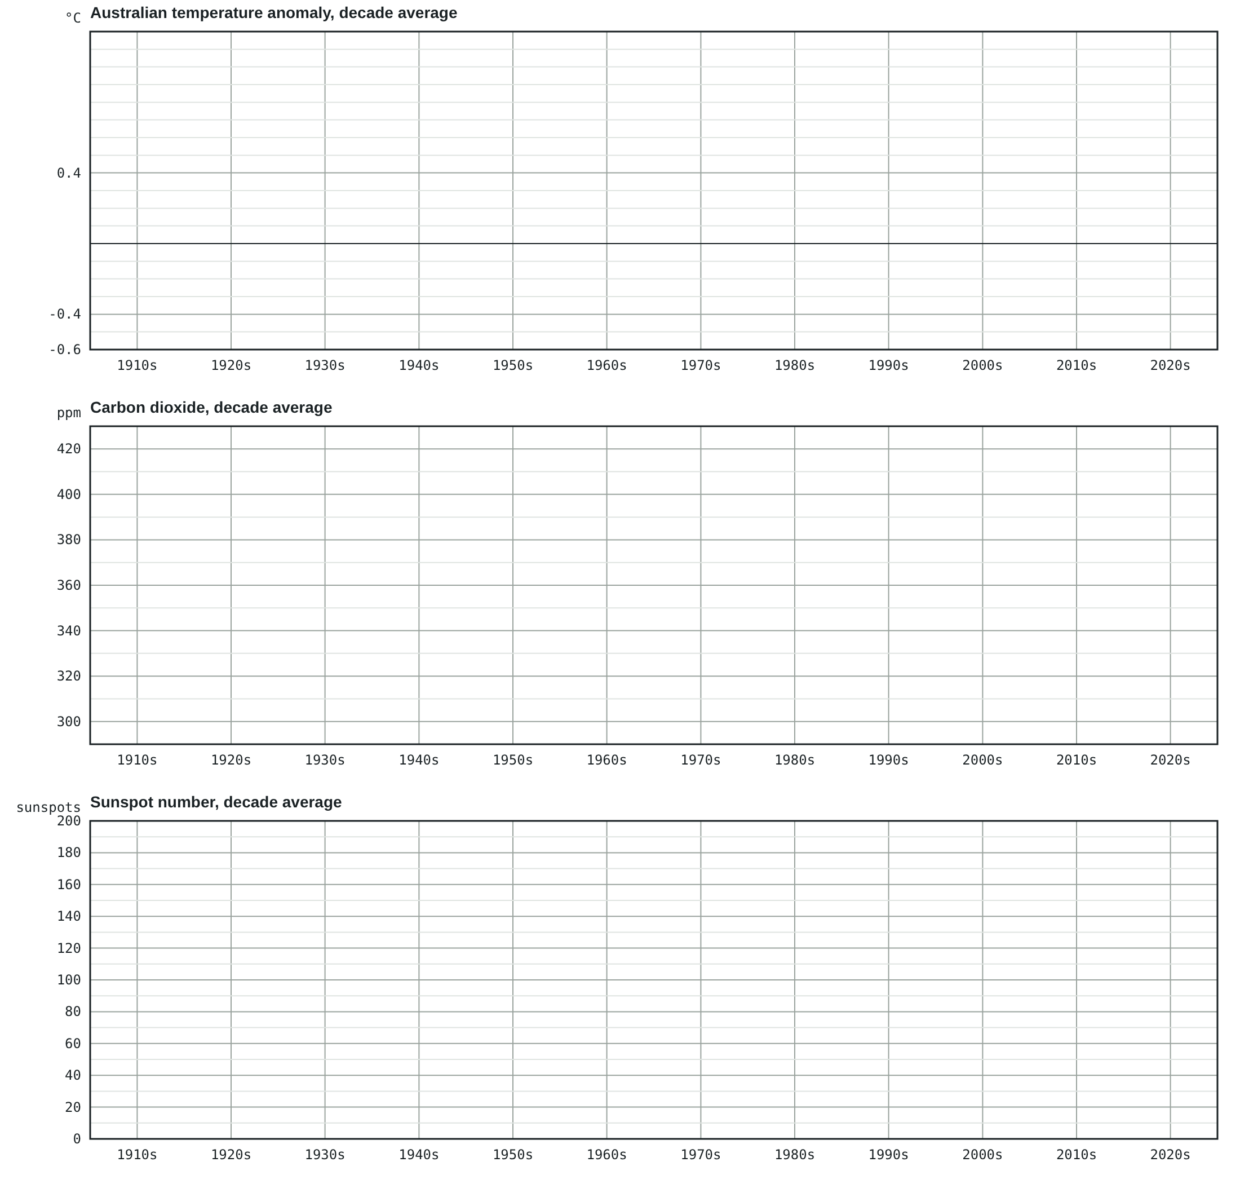
1. Describe the shape of each line in one sentence. Which two share a shape?

Your argument
Claim: what is driving the warming? One sentence.
Evidence. Three pieces, each with a number from the data and its source.
1. ____________________________________________________________ Source: ______________
2. ____________________________________________________________ Source: ______________
3. ____________________________________________________________ Source: ______________
Reasoning. How does each piece of evidence support the claim? Use the energy budget: what changed energy in or energy out?

The critic. Choose one objection and answer it with evidence: “The climate has always changed.” · “It’s the Sun.” · “CO2 is only 0.04% of the air.” · “The thermometers are in cities.”

Peer review
Do not write names on the argument or on this sheet. Use the codes your teacher gives you. Read the whole argument before you mark anything.
Argument code: __________ Reviewer code: __________
Criterion | Yes | Partly | No | Comment
The claim is stated in one clear sentence.
At least three pieces of evidence are given, each with a number and a source.
The reasoning explains how each piece of evidence supports the claim, using the energy budget.
At least one alternative cause is considered and ruled out with evidence.
The critic’s objection is answered with evidence, not with assertion or authority.
Terms are used correctly: energy budget, greenhouse effect, anomaly, fingerprint.
One thing this argument does well:

One thing it must fix before it would convince a scientist:

For the authors, after the review: what will you change?

FOR THE TEACHER · NOT FOR STUDENTS

Notes and answers
Purpose
The paper version of the lesson’s argument-driven inquiry: generate evidence by hand, build a claim, evidence and reasoning argument, face an objection, and review and revise. It goes with screens 3, 4, 7 and 9 of the online lesson but stands on its own (AC9S10U04; the Year 10 standard’s “construct logical arguments based on analysis of a variety of evidence to support conclusions and evaluate claims”).
Running it
- Plotting three lines of eleven points takes about 15 minutes. Pairs can split the grids.
- The decade averages smooth out El Niño years, which is the point: the shapes are what matter. Expect students to notice that temperature and CO2 both turn upward in the 1960s.
- For the review, give each pair an argument code and a reviewer code so the exchange is double blind. Allow 10 minutes to review and 10 to revise.
Answers
- (1) Temperature: flat or slightly falling to the 1950s, then rising, steeply after the 1970s (−0.45 °C in the 1910s to +0.86 °C in the 2010s). CO2: slow rise to the 1950s, then steeper every decade (about 300 to 400 ppm). Sunspots: up and down with no trend, highest in the 1950s, lowest in the 2010s. Temperature and CO2 share a shape; the Sun does not.
- Claim: the warming is real and driven mostly by greenhouse gases added by human activity. Evidence: the 1.3 °C rise between decade averages; the matching rise in CO2; the lack of any solar trend (the 2010s had the fewest sunspots of the century); the stratospheric cooling. Reasoning: more CO2 reduces the heat radiation escaping to space, so energy in exceeds energy out until the surface warms; a brighter Sun would do it too, but the Sun has not brightened, and it would warm the stratosphere, which has cooled.
- Critic: “always changed”: past changes had identifiable causes that are not changing now. “The Sun”: no trend, weaker recent cycles, cooling stratosphere. “0.04%”: nitrogen and oxygen do not absorb heat radiation; the trace gases and water vapour supply the 342 W/m² returned to the surface, and satellites see the extra absorption at CO2’s wavelengths. “Cities”: the Bureau excludes its four big-city sites from the national trend, and the sea, sea ice and sea level have no cities.
Extension
- Add the sea surface temperature series from the lesson and ask whether a sea with no cities can show an urban heat island.
- Give students the yearly values and ask why decade averages were used; then ask what a single record year (2019) proves on its own.

