OFFLINE ACTIVITY · YEAR 10 GEOGRAPHY · ENVIRONMENTAL CHANGE AND MANAGEMENT

Hold the line? Decision sheet.
Name: ____________________________________ Class: ______________
In March 2025 the waves from Cyclone Alfred moved millions of cubic metres of sand off the Gold Coast’s beaches. Use the data to judge six ways of managing this coast, then argue both sides of the question: should the Gold Coast keep holding the line?

Part A · The sand budget sand moved, in cubic metres (m³)
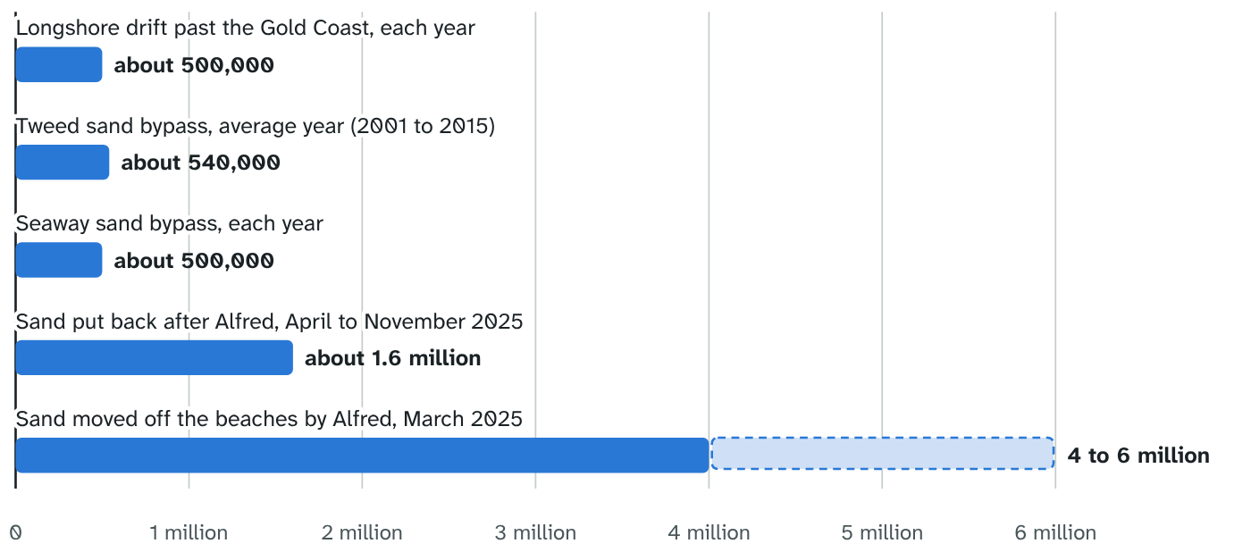
Sources: Tweed River Entrance Sand Bypassing Project; NCCARF case study; Gold Coast Waterways Authority; City of Gold Coast; ABC News (12 March and 4 December 2025).
1 Longshore drift carries about 500,000 m³ of sand along the Gold Coast each year. How many years of drift did Alfred move? Show your working.

2 Two sources give about 4 million m³ and 6 million m³. How would you report this in your own work, and why?

3 Name one human-induced change on this coast. Explain how it challenges the sustainability of the beaches.

Part B · Rate the strategies
Rate each strategy for each criterion: + helpful, ± mixed, − harmful. Then weight the criteria (1 matters a little, 3 matters a lot). Score each strategy: each rating (+1, 0 or −1) times its weight, added up.
STRATEGY | ENVIRONMENT | ECONOMY | PEOPLE | SCORE | BEST EVIDENCE
Weight (1 to 3)
Beach nourishment
Seawall (the A-line)
Sand bypassing
Artificial reef
Dune care
Managed retreat
4 Which strategy came out on top for you? Did changing the weights change the order? What does that tell you about your world view?

5 The Sand Motor in the Netherlands placed 21.5 million m³ of sand in one go, to feed the coast for at least 20 years. Could one big placement work better on the Gold Coast than repeated smaller ones? Give a reason.

Part C · The controversy should the Gold Coast keep holding the line?
Argue one side, hear the other side, then swap. Use the evidence from the lesson and Parts A and B.
Hold the line  OUR CLAIM  EVIDENCE 1  EVIDENCE 2  EVIDENCE 3 |  | Make room for the sea  OUR CLAIM  EVIDENCE 1  EVIDENCE 2  EVIDENCE 3
6 The strongest point the other side made against our first side, and how we answer it.

Part D · Our recommendation
Try: We recommend … in … because … The evidence shows … The strongest point against it is … but …
7 What should the Gold Coast do? You can combine strategies, and treat different places differently.

CRITERION | PREDICTED IMPACT OF OUR RECOMMENDATION
Environment
Economy
People
8 Which world view does your recommendation lean towards, ecocentric or technocentric? Explain.

